**DAILY ONLINE ACTIVITIES SUMMARY**

|  |  |  |  |  |  |  |  |  |
| --- | --- | --- | --- | --- | --- | --- | --- | --- |
| **Date:** | **05/06/2020** | | | | | **Name:** | **Pratibha Shetti** | |
| **Sem & Sec** | **IV sem & B section** | | | | | **USN:** | **4AL18CS0062** | |
| **Online Test Summary** | | | | | | | | |
| **Subject** | | **-** | | | | | | |
| **Max. Marks** | | **30** | | **Score** | | | **-** | |
| **Certification Course Summary** | | | | | | | | |
| **Course** | **Introduction to Cyber Security** | | | | | | | |
| **Certificate Provider** | | | **Greatlearning academy** | | **Duration** | | | **7.0 hours** |
| **Coding Challenges** | | | | | | | | |
| **Problem Statement1:** Write a Java Program to find the duplicate characters in a string. | | | | | | | | |
| **Status: Executed** | | | | | | | | |
| **Uploaded the report in Github** | | | | | **YES** | | | |
| **If yes Repository name** | | | | | <https://github.com/pratibhashetty-123/Lockdown-coding-java>  <https://github.com/pratibhashetty-123/Lockdown-coding-for-C> | | | |
| **Uploaded the report in slack** | | | | | **YES** | | | |

Online Test Summary: No internals conducted today.

Online Certification Course Summary: In today’s session I have learnt about Governance and Risk in Cyber Security and also learnt about Introduction to Cryptography what exactly cryptography is and encryption.

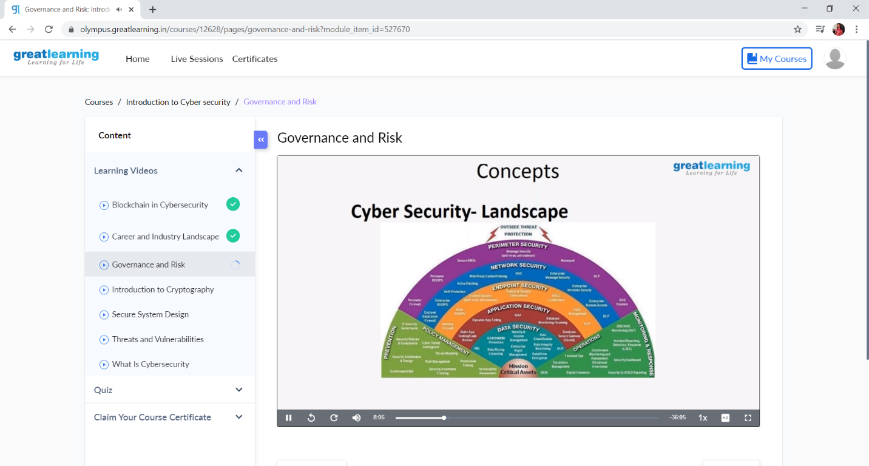

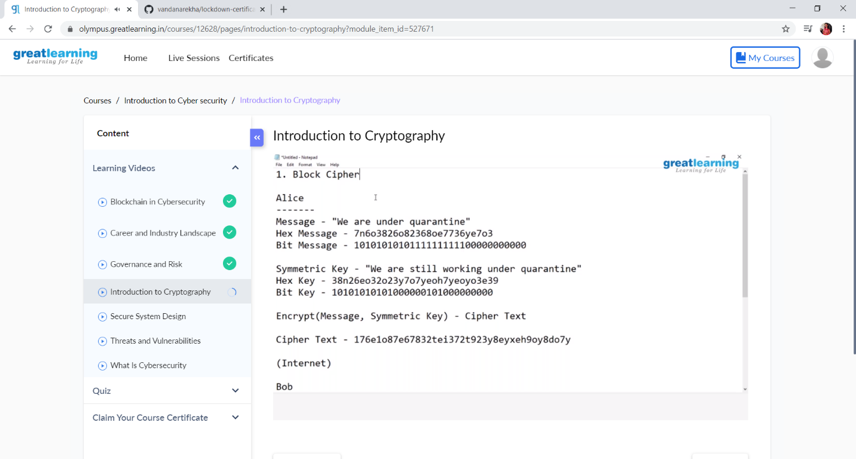

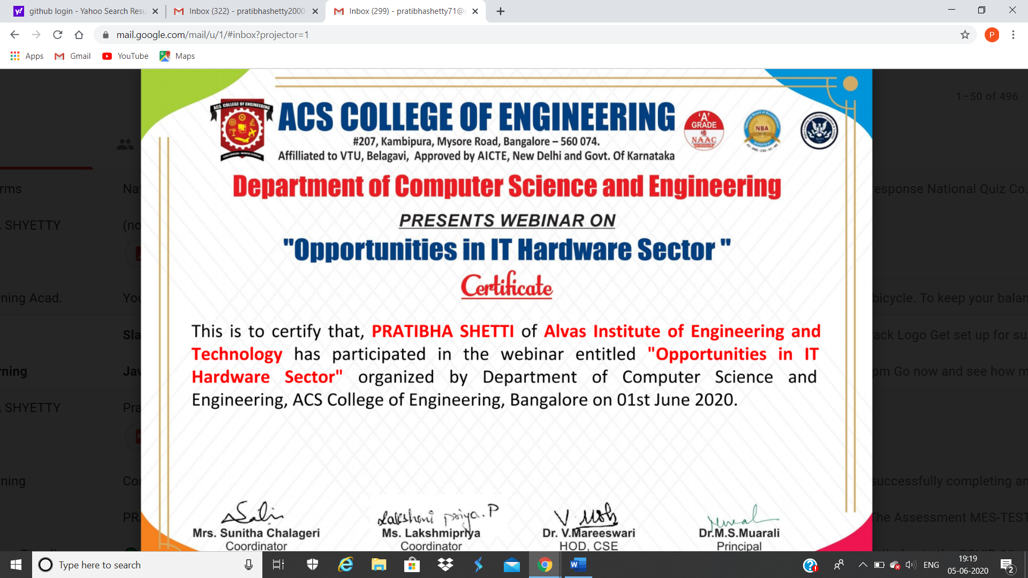

This is the snap shot of certificate for IT Hardware sector organized by ACs college

Online Coding Summary: **Today I had received one program from prof. Reena Lobo CSE Dept. The program is mentioned above in the coding challenges(pg.01). I have also uploaded it to my Github repository.**

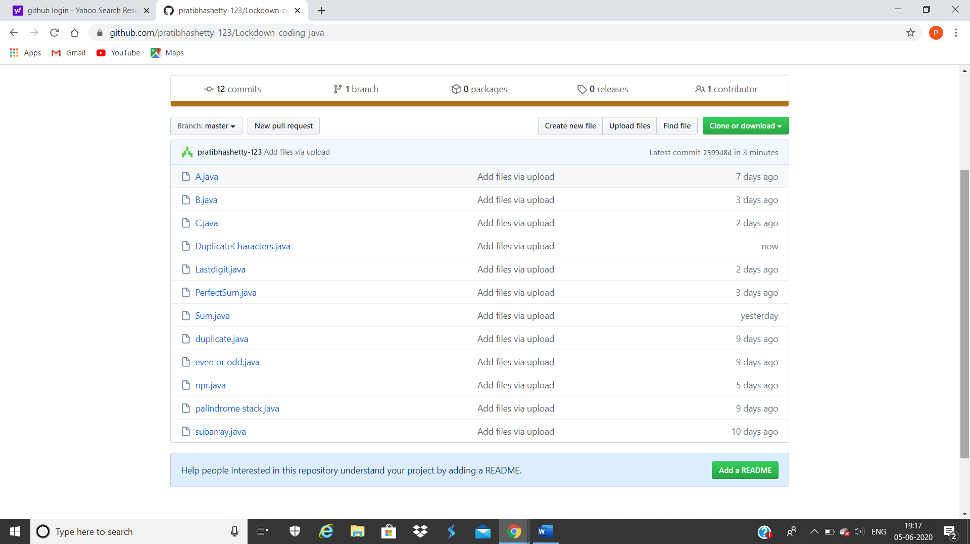

It is the snap shot of my repository were I have uploaded the code. File name is DuplicateCharacters.java